HALF ADDER
PROGRAM:
module HalfAdder(a, b, sum, carry);
input a;
input b;
output sum;
output carry;
xor g1(sum,a,b);
and g2(carry,a,b);
endmodule

OUTPUT
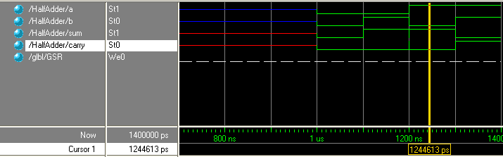

FULL ADDER
PROGRAM:
module FullAdder(a, b, cin, sum, carry);
input a;
input b;
input cin;
output sum;
output carry;
wire d,e,f;
xor g1(sum,a,b,cin);
and g2(d,a,b);
and g3(e,b,cin);
and g4(f,cin,a);
or g5(carry,d,e,f);
endmodule

OUTPUT
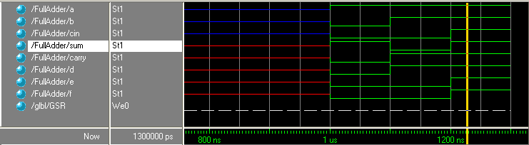

HALF SUBTRACTOR
PROGRAM:
module HalfSubtractor(a, b, difference, borrow);
input a;
input b;
output difference;
output borrow;
xor g1(difference,a,b);
not g2(c,a);
and g3(borrow,c,b);
endmodule

OUTPUT
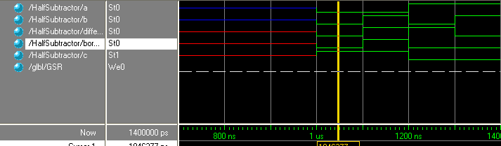

FULL SUBTRACTOR
PROGRAM:
module FullSub(a, b, c, diff, borrow);
input a;
input b;
input c;
output diff;
output borrow;
wire d,e,f,g;
xor g1(diff,a,b,c);
not g2(d,a);
and g3(e,d,b);
and g4(f,d,c);
and g5(g,b,c);
or g6(borrow,e,f,g);
endmodule

OUTPUT
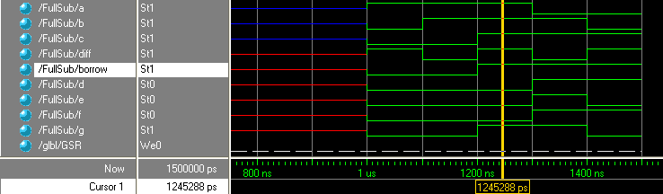

MULTIPLEXER
PROGRAM
module Mux(d, s, y);
input [0:3] d;
input [0:1] s;
output y;
wire a,b,c,e,f,g;
not g1(a,s[0]);
not g2(b,s[1]);
and g3(c,d[0],a,b);
and g4(e,d[1],a,s[1]);
and g5(f,d[2],s[0],b);
and g6(g,d[3],s[0],s[1]);
or g7(y,c,e,f,g);
endmodule

OUTPUT
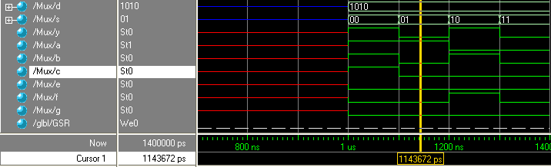

DEMULTIPLEXER
PROGRAM
module DeMux(y, s, d);
input y;
input [0:1] s;
output [0:3] d;
wire a,b;
not g1(a,s[0]);
not g2(b,s[1]);
and g3(d[0],y,a,b);
and g4(d[1],y,a,s[1]);
and g5(d[2],y,s[0],b);
and g6(d[3],y,s[0],s[1]);
endmodule

OUTPUT
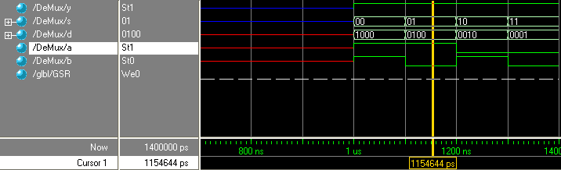

ENCODER
PROGRAM
module Encoder(y, a, b);
input [0:3] y;
output a;
output b;
or g1(a,y[2],y[3]);
or g2(b,y[1],y[3]);
endmodule

OUTPUT
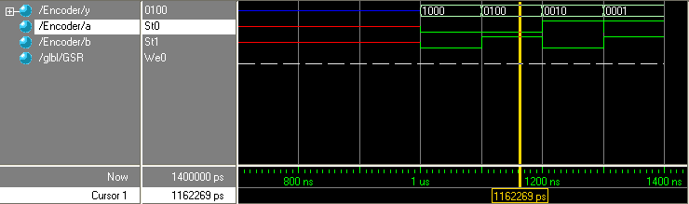

DECODER
PROGRAM
module Decoder(a, b, en, y);
input a;
input b;
input en;
output [0:3] y;
wire c,d;
not g1(c,a);
not g2(d,b);
nand g3(y[0],c,d,en);
nand g4(y[1],c,b,en);
nand g5(y[2],a,d,en);
nand g6(y[3],a,b,en);
endmodule

OUTPUT
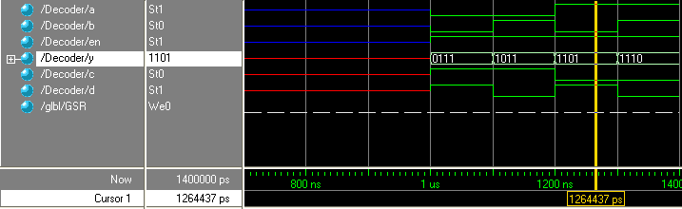

D FLIP FLOP
PROGRAM:
module DFlipFlop(d, clk, clr, q, qbar);
input d;
input clk;
input clr;
output q;
output qbar;
reg q;
assign qbar=~q;
always @(posedge clk)
if(~clr)q=0;
else q=d;
endmodule

OUTPUT
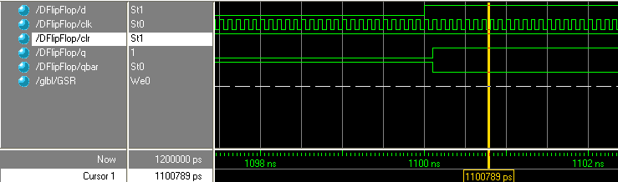

T FLIP FLOP
PROGRAM:
module TFlipFlop(t, clk, q, qbar);
input t;
input clk;
output q;
output qbar;
reg q;
assign qbar=~q;
always @ (posedge clk)
q=~t;
endmodule

OUTPUT

