Aim :

Ex. No : 1 | STUDY OF MATLAB | Date :

Result :

Aim :

Ex. No : 2 | GENERATION OF SIGNALS | Date :

Program :
%program to generate unit impulse signal
clc;
clear all;
close all;
t=-2:1:2;
y=[zeros(1,2),ones(1),zeros(1,2)];
figure;
stem(t,y);
ylabel('Amplitude--------->');
xlabel('Time------------>');
title('Unit Impulse Signal');

Output :

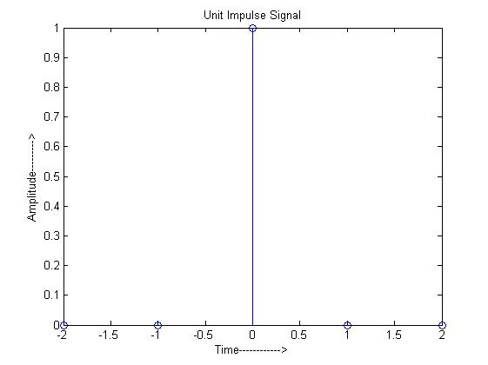

Program :
%Program to generate unit step signal(discrete signal);
clc;
close all;
clear all;
n=input('Enter the length of the sequence');
t=0:1:n-1;
y=[ones(1,n)];
stem(t,y);
ylabel('Amplitude------>');
xlabel('Time------>');
title('Unit step signal');

Output :
Enter the length of the sequence10
>>

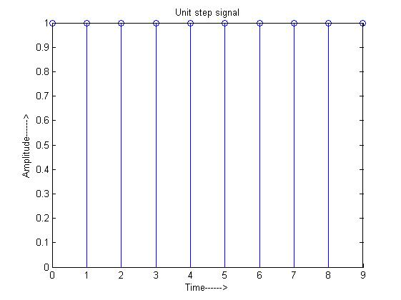
Program :

%Program to generate the unit step signal (continuous signal) ;
clc;
clear all;
close all;
n=input('Enter the length of the sequence');
t=0:1:n-1;
y=[ones(1,n)];
plot(t,y);
ylabel('Amplitude---------->');
xlabel('Time-------->');
title('Unit step signal');

Output :
Enter the length of the sequence10
>>

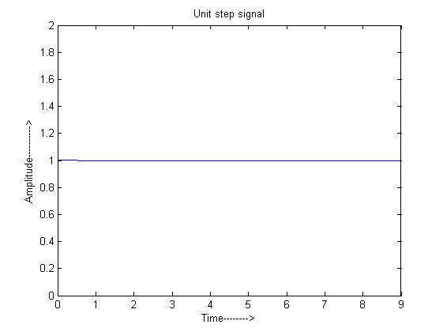

Program :
%Program to generate unit ramp signal(discrete signal);
clc;
clear all;
close all;
n=input('Enter the length of the sequence');
t=0:1:n-1;
stem(t,t);
ylabel('Amplitude------>');
xlabel('Time-------->');
title('Unit ramp signal');

Output :
Enter the length of the sequence10
>>

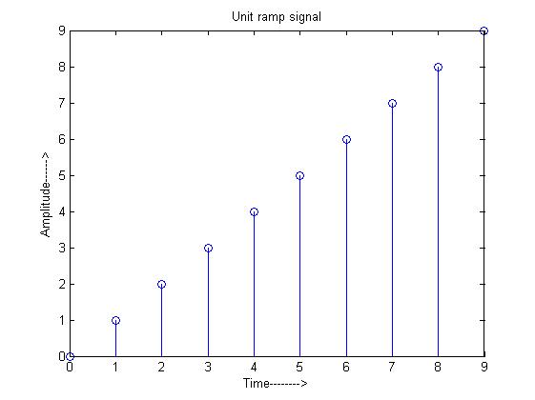
Program :
%Program to generate unit ramp signal(continuous signal);
clc;
clear all;
close all;
n=input('Enter the length of the sequence');
t=0:1:n-1;
plot(t,t);
ylabel('Amplitude----->');
xlabel('Time---->');
title('Unit ramp signal');

Output :
Enter the length of the sequence10
>>

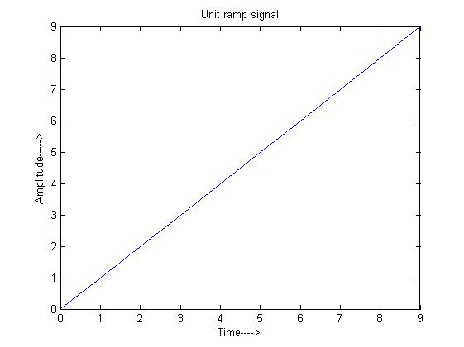
Program :
%Program to generate sinusoidal signal;
clc;
clear all;
close all;
f=input('Enter the frequency of the signal');
t=0:0.01:pi;
y=sin(2*pi*f*t);
plot(t,y);
ylabel('Amplitude-------->');
xlabel('Time--------->');
title('Sinusoidal signal');

Output :
Enter the frequency of the signal1
>>

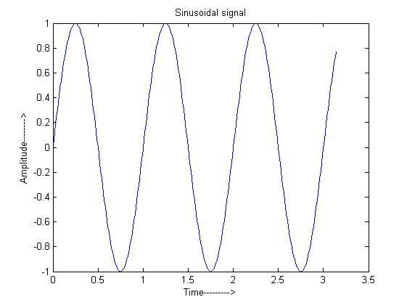
Program :
%Program to generate co sinusoidal signal;
clc;
clear all;
close all;
f=input('Enter the frequency of the signal');
t=0:0.01:pi;
y=cos (2*pi*f*t);
plot(t,y);
ylabel('Amplitude-------->');
xlabel('Time----->');
title('Co sinusoidal signal');

Output :
Enter the frequency of the signal1
>>

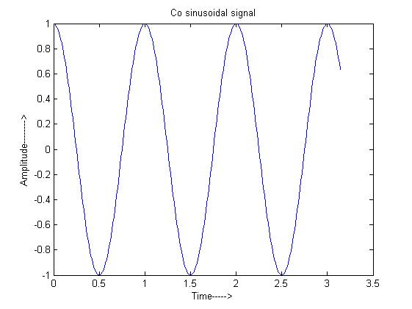

Program :
%Program to generate discrete time signal;
clc;
clear all;
close all;
x=input('Enter the sequence');
figure;
stem(x);
ylabel('Amplitude-------->');
xlabel('Time--------->');
title('Discrete time signal');

Output :
Enter the sequence[1 3 -5 2]
>>

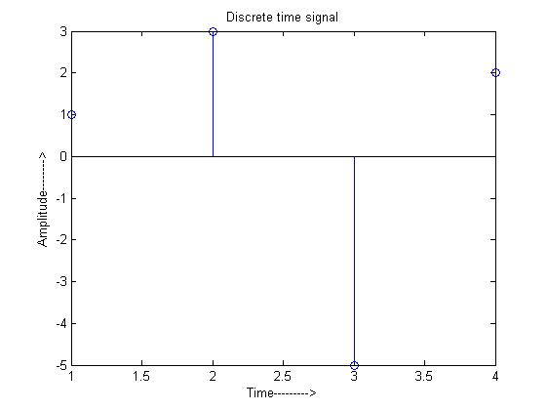

Result :

Aim :

Algorithm :

Ex. No : 3 | IMPLEMENTATION OF FFT | Date :
Program:
%Program to calculate FFT;
clc;
clear all;
close all;
x=input('Enter the input sequence');
y=fft(x);
subplot(2,1,1);
stem(x);
xlabel('Time------->');
ylabel('Amplitude----------->');
subplot(2,1,2);
stem(y);
xlabel('Time-------->');
ylabel('Amplitude---------->');
disp('Input sequence');x
disp('FFT values');y
title('Calculation of FFT');

Output:
Enter the input sequence[1 2 3 4 4 3 2 1]
Input sequence
x =
1 2 3 4 4 3 2 1
FFT values
y =
Columns 1 through 6
20.0000 -5.8284 - 2.4142i 0 -0.1716 - 0.4142i 0 -0.1716 + 0.4142i
Columns 7 through 8
0 -5.8284 + 2.4142i
>>

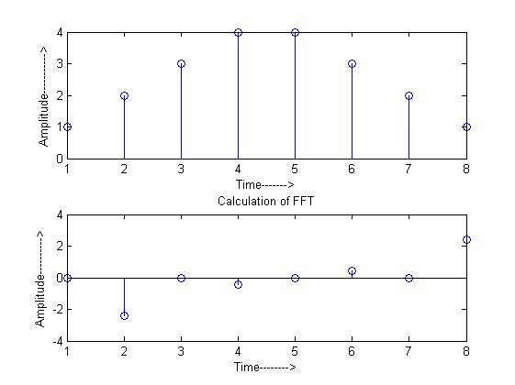

Result:
Ex. No : 4 | IMPLEMENTATION OF DFT | Date :

Aim :

Algorithm :

Program :
%Program to calculate DFT
clc;
clear all;
close all;
x=input('Enter the sequence');
N=length(x);
for k=0:1:N-1;
for n=0:1:N-1;
p=exp(-i*2*pi*k*n/N);
y(n+1,k+1)=p;
end;
end;
y=x*y;
disp(y);
subplot(2,1,1);
stem(x);
xlabel('Time-------->');
ylabel('Amplitude---------->');
title('Input sequence');
subplot(2,1,2);
stem(y);
xlabel('Time-------->');
ylabel('Amplitude---------->');
title('DFT sequence');

Output :
Enter the sequence[1 2 3 4]
10.0000 -2.0000 + 2.0000i -2.0000 - 0.0000i -2.0000 - 2.0000i

>>
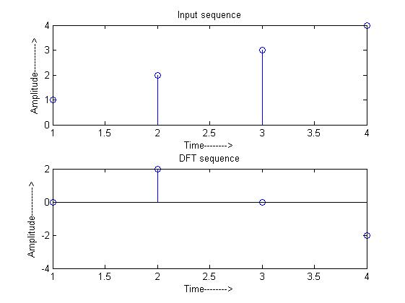

Result :

Aim :

Algorithm :

Ex. No : 5 | LINEAR & CIRCULAR CONVOLUTION | Date :

Program :
%Program to calculate linear convolution;
clc;
clear all;
close all;
x1=input('Enter the input sequence');
x2=input('Enter the input sequence');
y=convn(x1,x2);
subplot(3,1,1);
stem(x1);
ylabel('Amplitude-------->');
xlabel('Time---------->');
title('Input sequence x1');
subplot(3,1,2);
stem(x2);
ylabel('Amplitude-------->');
xlabel('Time---------->');
title('Input sequence x2');
subplot(3,1,3);
stem(y);
ylabel('Amplitude-------->');
xlabel('Time---------->');
disp('Input sequence x1');
disp(x1);
disp('Input sequence x2');
disp(x2);
disp('Convn value y');
disp(y);
title('Convolution');

Output :
Enter the input sequence[0 1 2 3]
Enter the input sequence[1 2 3 4]
Input sequence x1
0 1 2 3
Input sequence x2
1 2 3 4
Convn value y
0 1 4 10 16 17 12
>>

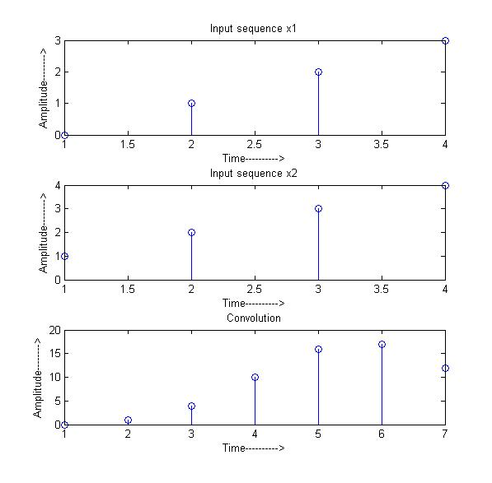
Program :
%Program to calculate circular convolution;
clc;
clear all;
close all;
x=input('Enter the input sequence(x)');
h= input('Enter the input sequence(h)');
y=fft(x);
n=fft(h);
for i=1:length(x)
s(i)=y(i)*n(i);
end
z=ifft(s);
subplot(3,1,1);
stem(x);
ylabel('Amplitude-------->');
xlabel('Time---------->');
title('x(n)');
subplot(3,1,2);
stem(h);
ylabel('Amplitude-------->');
xlabel('Time---------->');
title('h(n)');
subplot(3,1,3);
stem(z);
ylabel('Amplitude-------->');
xlabel('Time---------->');
disp('Input sequence x(n)');
disp(x);
disp('Input sequence');
disp(h);
disp('Convn values');
disp(z);
title('Circular Convolution');
Output :

Enter the input sequence(x)[0 1 2 3]
Enter the input sequence(h)[1 2 3 4]
Input sequence x(n)
0 1 2 3
Input sequence
1 2 3 4
Convn values
16 18 16 10
>>

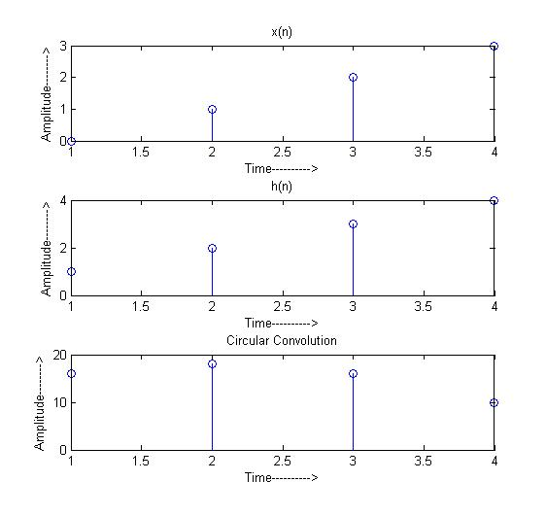

Result :

Aim :

Algorithm :

Ex. No : 6 | SAMPLING THEOREM | Date :

Program:
%Solution for section(a);
clc;
clear all;
close all;
f1=1/128;
f2=5/128;
n=0:255;
fc=50/128;
x=cos(2*pi*f1*n)+cos(2*pi*f2*n);
xa=cos(2*pi*fc*n);
xamp=x.*xa;
subplot(2,2,1);
plot(n,x);
title('x(n)');
xlabel('n------>');
ylabel('Amplitude--------?');
subplot(2,2,2);
plot(n,xa);
title('xa(n)');
xlabel('n------>');
ylabel('Amplitude--------?');
subplot(2,2,3);
plot(n,xamp);
xlabel('n-------->');
ylabel('Amplitude--------->');

%128 point DFT computation-solution for section(b);
n=0:127;
figure;
n1=128;
f1=1/128;
f2=5/128;
fc=50/128;
x=cos(2*pi*f1*n)+ cos(2*pi*f2*n);
xc= cos(2*pi*fc*n);
xamp=x.*xc;
xam=fft(xamp,n1);
stem(n,xam);
title('xamp(n)');
xlabel('n-------->');
ylabel('Amplitude--------->');

%128 point DFT computation-solution for section(c);
n=0:99;
figure;
n2=0:n1-1;
f1=1/128;
f2=5/128;
fc=50/128;
x=cos(2*pi*f1*n)+ cos(2*pi*f2*n);
xc= cos(2*pi*fc*n);
xamp=x.*xc;
for i=1:100
xamp1(i)=xamp(i);
end
xam=fft(xamp1,n1);
stem(n2,xam);
title('xamp(n)');
xlabel('n-------->');
ylabel('Amplitude--------->');

Output:
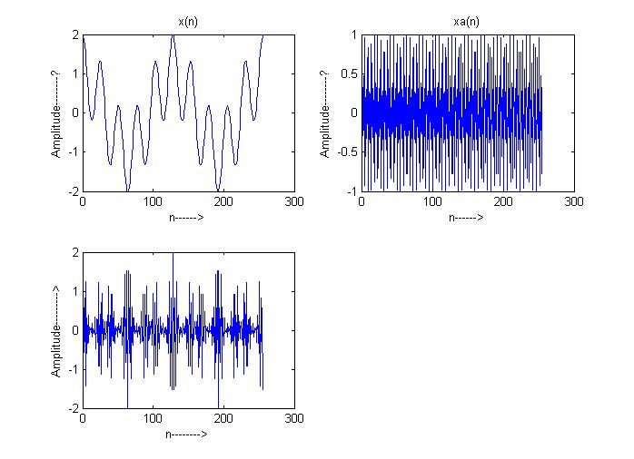

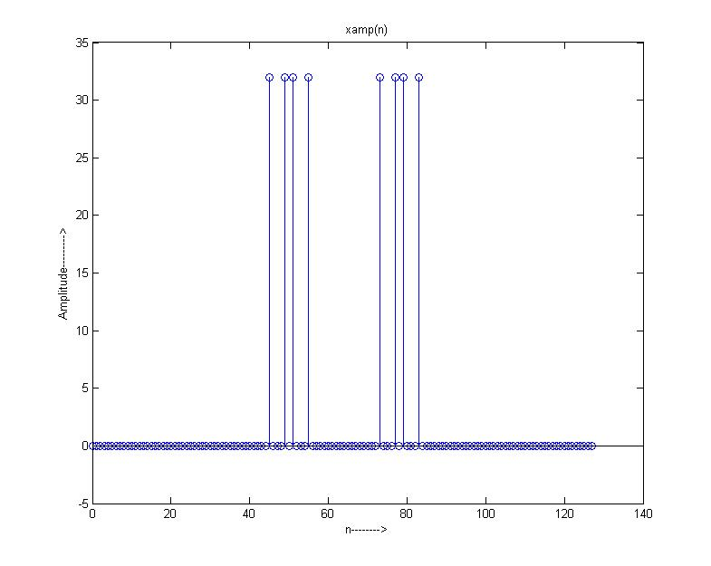

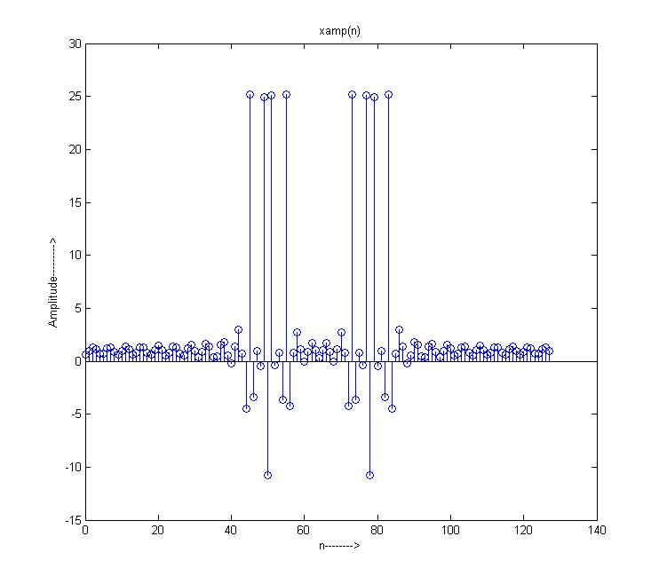

Result :

Ex. No : 7 | INTERPOLATION | Date :

Aim :

Algorithm :

Program :
%Program for interpolation
clc;
clear all;
close all;
N=input('input length=');
L=input('up-sampling factor=');
f0=input('input signal frequency=');
%generate the input sinusoidal sequence%
n=0:N-1;
x=sin(2*pi*f0*n);
%generate the up sampled sequence%
y=zeros (1,L*length(x));
y([1:L:length(y)])=x;
%to plot the input and output sequences
subplot(2,1,1);
stem(n,x);
xlabel('time index n');
ylabel('amplitude');
title('input sequence');
subplot(2,1,2);
stem(n,y (1:length(x)));
xlabel('time index n');
ylabel('amplitude');
title(['output sequence up-sampled by:num2str(L)']);

Output :
input length=50
up -sampling factor=3
input signal frequency=.2
>>

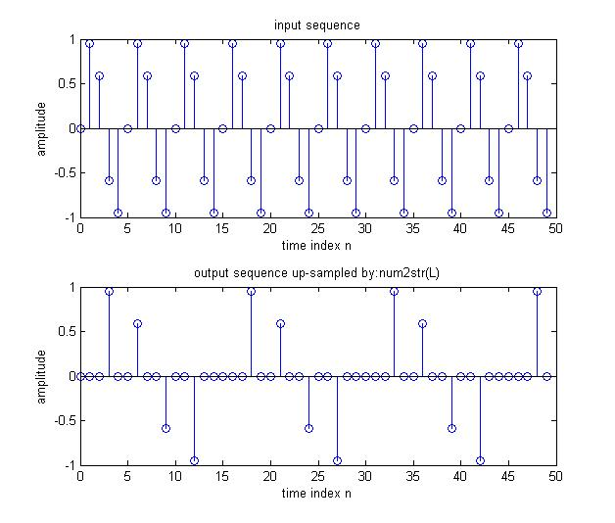

Result :

Aim :

Algorithm :

Ex. No : 8 | DECIMATION | Date :

Program :
%Program for decimation
clc;
close all;
clear all;
N=input('output length=');
M=input('down sampling factor=');
f0=input('input signal frequency=');
%generate the input sinusoidal sequence%
n=0 : N-1;
m=0 : N*M-1;
x=sin(2*pi*f0*m);
%generate the down sampled sequence%
y=x([1:M:length(x)]);
%to plot the input and output sequence%
subplot(2,1,1);
stem(n,x(1:N));
title('input sequence');
subplot(2,1,2);
stem(n,y);
title(['output sequence down sampled by:num2str(m)']);
xlabel('time index');
ylabel('amplitude');

Output :
output length=50
down sampling factor=3
input signal frequency=.2
>>

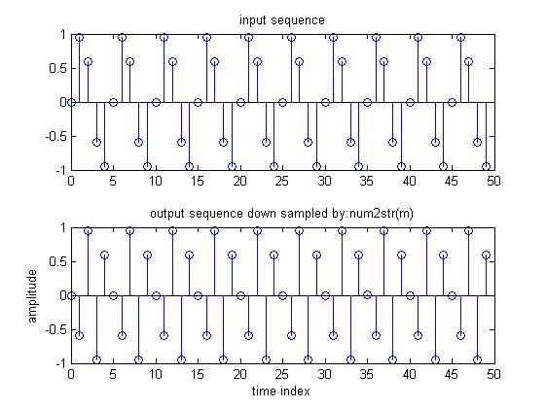

Result :

Ex. No : 9 | FIR FILTER DESIGN-RECTANGULAR WINDOW | Date :
Aim :

Algorithm :

Program :
%Program for design FIR lowpass, bandpass, band stop filter using rectangular window;
clc;
clear all;
close all;
rp=input('Enter the pass band ripple');
rs=input('Enter the stop band ripple');
fp=input('Enter the pass band frequency');
fs=input('Enter the stop band frequency');
f=input('Enter the sampling frequency');
wp=2*fp/f;
ws=2*fs/f;
num=-20*log10(sqrt(rp*rs))-13;
dem=14.6*(fs-fp)/f;
n=ceil(num/dem);
n1=n+1;
if(rem(n,2)~=0);
n1=n;
n=n-1;
end
y=boxcar(n1);
%low pass filter;
b=fir1(n,wp,y);
[h,o]=freqz(b,1,256);
m=20*log10(abs(h));
subplot(2,2,1);
plot(o/pi,m);
xlabel('(a)Normalized frequency------------->');
ylabel('Gain in dB--------->');

%High pass filter;
b=fir1(n,wp,'high',y);
[h,o]=freqz(b,1,256);
m=20*log10(abs(h));
subplot(2,2,2);
plot(o/pi,m);
xlabel('(b)Normalized frequency------------->');
ylabel('Gain in dB--------->');

%Band pass filter;
wn=[wp,ws];
b=fir1(n,wn,y);
[h,o]=freqz(b,1,256);
m=20*log10(abs(h));
subplot(2,2,3);
plot(o/pi,m);
xlabel('(c)Normalized frequency------------->');
ylabel('Gain in dB--------->');

%Band stop filter;
b=fir1(n,wn,'stop',y);
[h,o]=freqz(b,1,256);
m=20*log10(abs(h));
subplot(2,2,4);
plot(o/pi,m);
xlabel('(d)Normalized frequency------------->');
ylabel('Gain in dB--------->');

Output :
Enter the pass band ripple0.05
Enter the stop band ripple0.04
Enter the pass band frequency1500
Enter the stop band frequency2000
Enter the sampling frequency9000
>>

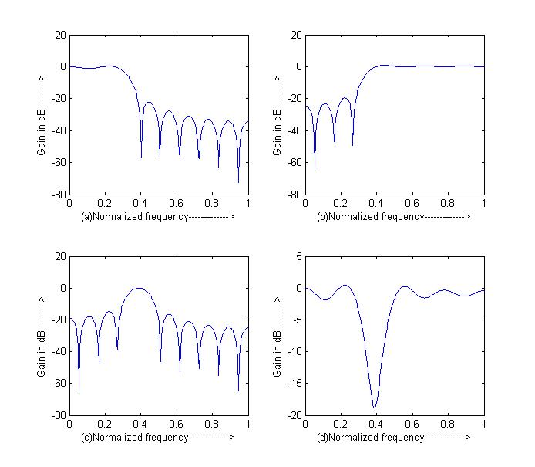

Result :

Ex. No : 10 | FIR FILTER DESIGN-HAMMING WINDOW | Date :
Aim :

Algorithm :

Program :
%Design of FIR filter using Hamming window;
clc;
clear all;
close all;
rp=input('Enter the pass band ripple');
rs=input('Enter the stop band ripple');
fp=input('Enter the pass band frequency');
fs=input('Enter thestop band frequency');
f=input('Enter the sampling frequency');
wp=2*fp/f;
ws=2*fs/f;
num=-20*log10(sqrt(rp*rs))-13;
dem=14.6*(fs-fp)/f;
n=ceil(num/dem);
n1=n+1;
if(rem(n,2)~=0);
n1=n;
n=n-1;
end
y=hamming(n1);
%low pass filter;
b=fir1(n,wp,y);
[h,o]=freqz(b,1,256);
m=20*log10(abs(h));
subplot(2,2,1);
plot(o/pi,m);
xlabel('(a)Normalized frequency------------->');
ylabel('Gain in dB--------->');

%High pass filter;
b=fir1(n,wp,'high',y);
[h,o]=freqz(b,1,256);
m=20*log10(abs(h));
subplot(2,2,2);
plot(o/pi,m);
xlabel('(b)Normalized frequency------------->');
ylabel('Gain in dB--------->');

%Band pass filter;
wn=[wp,ws];
b=fir1(n,wn,y);
[h,o]=freqz(b,1,256);
m=20*log10(abs(h));
subplot(2,2,3);
plot(o/pi,m);
xlabel('(c)Normalized frequency------------->');
ylabel('Gain in dB--------->');

%Band stop filter;
b=fir1(n,wn,'stop',y);
[h,o]=freqz(b,1,256);
m=20*log10(abs(h));
subplot(2,2,4);
plot(o/pi,m);
xlabel('(d)Normalized frequency------------->');
ylabel('Gain in dB--------->');

Output :
Enter the pass band ripple0.02
Enter the stop band ripple0.01
Enter the pass band frequency1200
Enter thestop band frequency1700
Enter the sampling frequency9000
>>

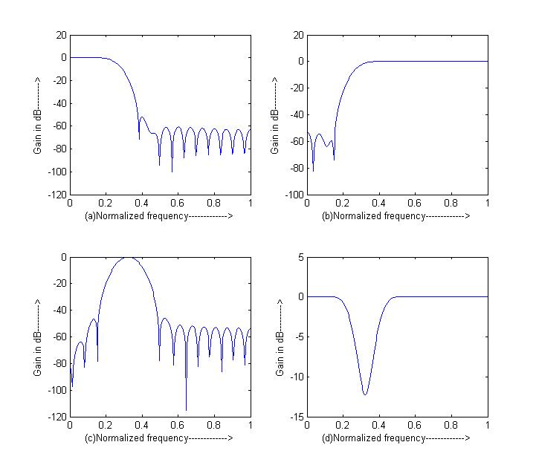

Result :

Ex. No : 11 | FIR FILTER DESIGN-HANNING WINDOW | Date :
Aim :

Algorithm :

Program :
%Design of FIR filter using Hanning window;
clc;
clear all;
close all;
rp=input('Enter the pass band ripple');
rs=input('Enter the stop band ripple');
fp=input('Enter the pass band frequency');
fs=input('Enter the stop band frequency');
f=input('Enter the sampling frequency');
wp=2*fp/f;
ws=2*fs/f;
num=-20*log10(sqrt(rp*rs))-13;
dem=14.6*(fs-fp)/f;
n=ceil(num/dem);
n1=n+1;
if(rem(n,2)~=0);
n1=n;
n=n-1;
end
y=hanning(n1);

%low pass filter;
b=fir1(n,wp,y);
[h,o]=freqz(b,1,256);
m=20*log10(abs(h));
subplot(2,2,1);
plot(o/pi,m);
xlabel('(a)Normalized frequency------------->');
ylabel('Gain in dB--------->');

%High pass filter;
b=fir1(n,wp,'high',y);

[h,o]=freqz(b,1,256);
m=20*log10(abs(h));
subplot(2,2,2);
plot(o/pi,m);
xlabel('(b)Normalized frequency------------->');
ylabel('Gain in dB--------->');

%Band pass filter;
wn=[wp,ws];
b=fir1(n,wn,y);
[h,o]=freqz(b,1,256);
m=20*log10(abs(h));
subplot(2,2,3);
plot(o/pi,m);
xlabel('(c)Normalized frequency------------->');
ylabel('Gain in dB--------->');

%Band stop filter;
b=fir1(n,wn,'stop',y);
[h,o]=freqz(b,1,256);
m=20*log10(abs(h));
subplot(2,2,4);
plot(o/pi,m);
xlabel('(d)Normalized frequency------------->');
ylabel('Gain in dB--------->');

Output:

Enter the pass band ripple0.03
Enter the stop band ripple0.01
Enter the pass band frequency1400
Enter the stop band frequency2000
Enter the sampling frequency8000
>>
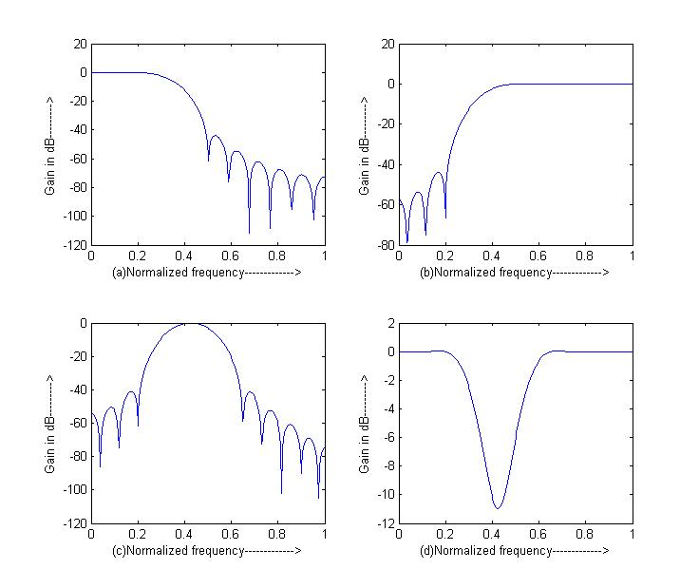

Result :

Aim :

Algorithm :

Ex. No : 12 | BUTTERWORTH DIGITAL IIR FILTERS | Date :

Program :
%Program for the design of Butterworth low pass filter;
clc;
clear all;
close all;
format long
rp=input('Enter the pass band ripple');
rs=input('Enter the stop band ripple');
fp=input('Enter the pass band frequency');
fs=input('Enter the stop band frequency');
f=input('Enter the sampling frequency');
wp=2*fp/f;
ws=2*fs/f;
[n,wn]=buttord(wp,ws,rp,rs);
[b,a]=butter(n,wn);
w=0:.01:pi;
[h,om]=freqz(b,a,w);
m=20*log10(abs(h));
an=angle(h);
subplot(2,1,1);
plot(om/pi,m);
xlabel('(a)Normalized frequency------------->');
ylabel('Gain in dB--------->');
subplot(2,1,2);
plot(om/pi,an);
xlabel('(b)Normalized frequency------------->');
ylabel('Phase in radians--------->');

Output :
Enter the pass band ripple0.5
Enter the stop band ripple50
Enter the pass band frequency1200
Enter the stop band frequency2400
Enter the sampling frequency10000
>>

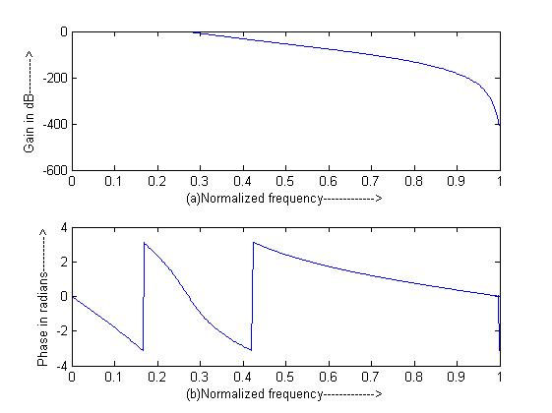

Program :
%Program for design Butterworth high pass filter;
clc;
clear all;
close all;
format long
rp=input('Enter the pass band ripple');
rs=input('Enter the stop band ripple');
fp=input('Enter the pass band frequency');
fs=input('Enter the stop band frequency');
f=input('Enter the sampling frequency');
wp=2*fp/f;
ws=2*fs/f;
[n,wn]=buttord(wp,ws,rp,rs);
[b,a]=butter(n,wn,'high');
w=0:.01:pi;
[h,om]=freqz(b,a,w);
m=20*log10(abs(h));
an=angle(h);
subplot(2,1,1);
plot(om/pi,m);
xlabel('(a)Normalized frequency------------->');
ylabel('Gain in dB--------->');
subplot(2,1,2);
plot(om/pi,an);
xlabel('(b)Normalized frequency------------->');
ylabel('Phase in radians--------->');

Output :
Enter the pass band ripple0.5
Enter the stop band ripple50
Enter the pass band frequency1200
Enter the stop band frequency2400
Enter the sampling frequency10000
>>

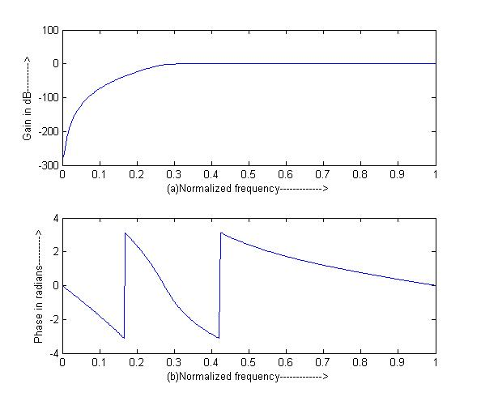

Program :
%Program for design Butterworth band pass digital filter;
clc;
clear all;
close all;
format long
rp=input('Enter the pass band ripple');
rs=input('Enter the stop band ripple');
fp=input('Enter the pass band frequency');
fs=input('Enter thestop band frequency');
f=input('Enter the sampling frequency');
wp=2*fp/f;
ws=2*fs/f;
[n]=buttord(wp,ws,rp,rs);
[wn]=[wp ws];
[b,a]=butter(n,wn,'bandpass');
w=0:.01:pi;
[h,om]=freqz(b,a,w);
m=20*log10(abs(h));
an=angle(h);
subplot(2,1,1);
plot(om/pi,m);
xlabel('(a)Normalized frequency------------->');
ylabel('Gain in dB--------->');
subplot(2,1,2);
plot(om/pi,an);
xlabel('(b)Normalized frequency------------->');
ylabel('Phase in radians--------->');

Output :
Enter the pass band ripple0.3
Enter the stop band ripple40
Enter the pass band frequency1500
Enter thestop band frequency2000
Enter the sampling frequency9000
>>

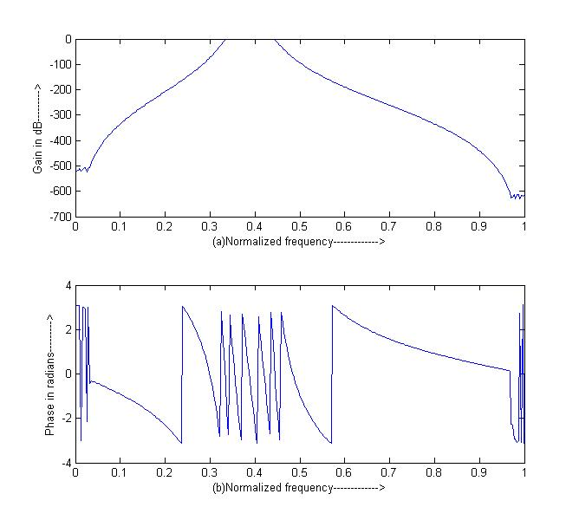

Program :
%Program for design Butterworth band stop digital filter;
clc;
clear all;
close all;
format long
rp=input('Enter the pass band ripple');
rs=input('Enter the stop band ripple');
fp=input('Enter the pass band frequency');
fs=input('Enter the stop band frequency');
f=input('Enter the sampling frequency');
wp=2*fp/f;
ws=2*fs/f;
[n]=buttord(wp,ws,rp,rs);
[wn]=[wp ws];
[b,a]=butter(n,wn,'stop');
w=0:.01:pi;
[h,om]=freqz(b,a,w);
m=20*log10(abs(h));
an=angle(h);
subplot(2,1,1);
plot(om/pi,m);
xlabel('(a)Normalized frequency------------->');
ylabel('Gain in dB--------->');
subplot(2,1,2);
plot(om/pi,an);
xlabel('(b)Normalized frequency------------->');
ylabel('Phase in radians--------->');

Output :
Enter the pass band ripple0.4
Enter the stop band ripple46
Enter the pass band frequency1100
Enter the stop band frequency2200
Enter the sampling frequency6000
>>

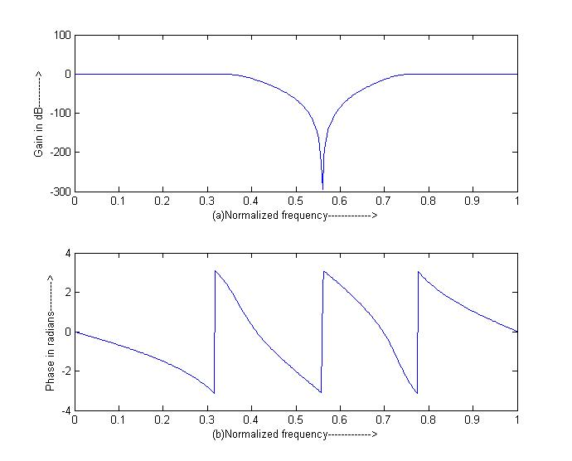

Result :

Ex. No : 13 | INTRODUCTION TO DSP PROCESSOR | Date :
Aim :

Result :

Ex. No : 14 | FIR FILTER USING DSP PROCESSOR | Date :
Aim :

Algorithm :

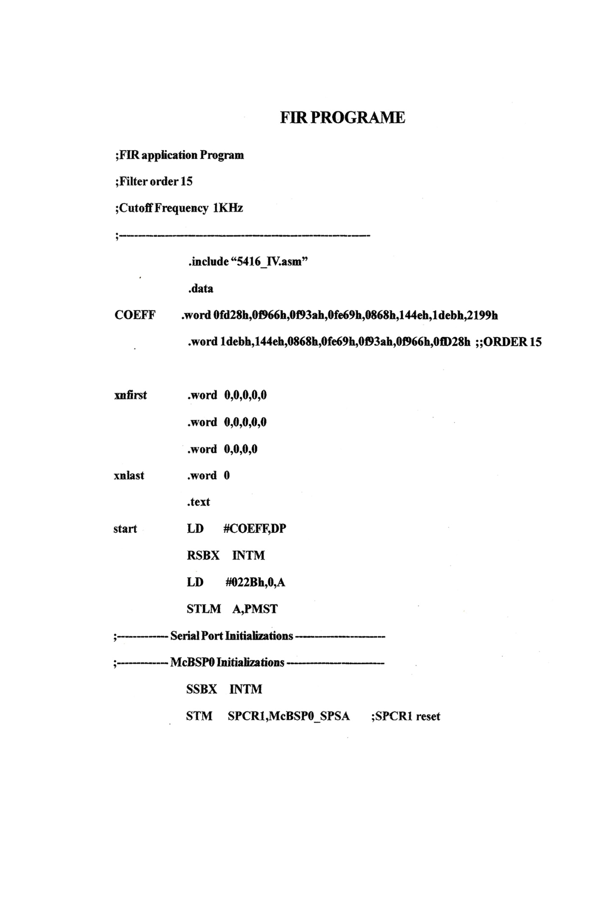

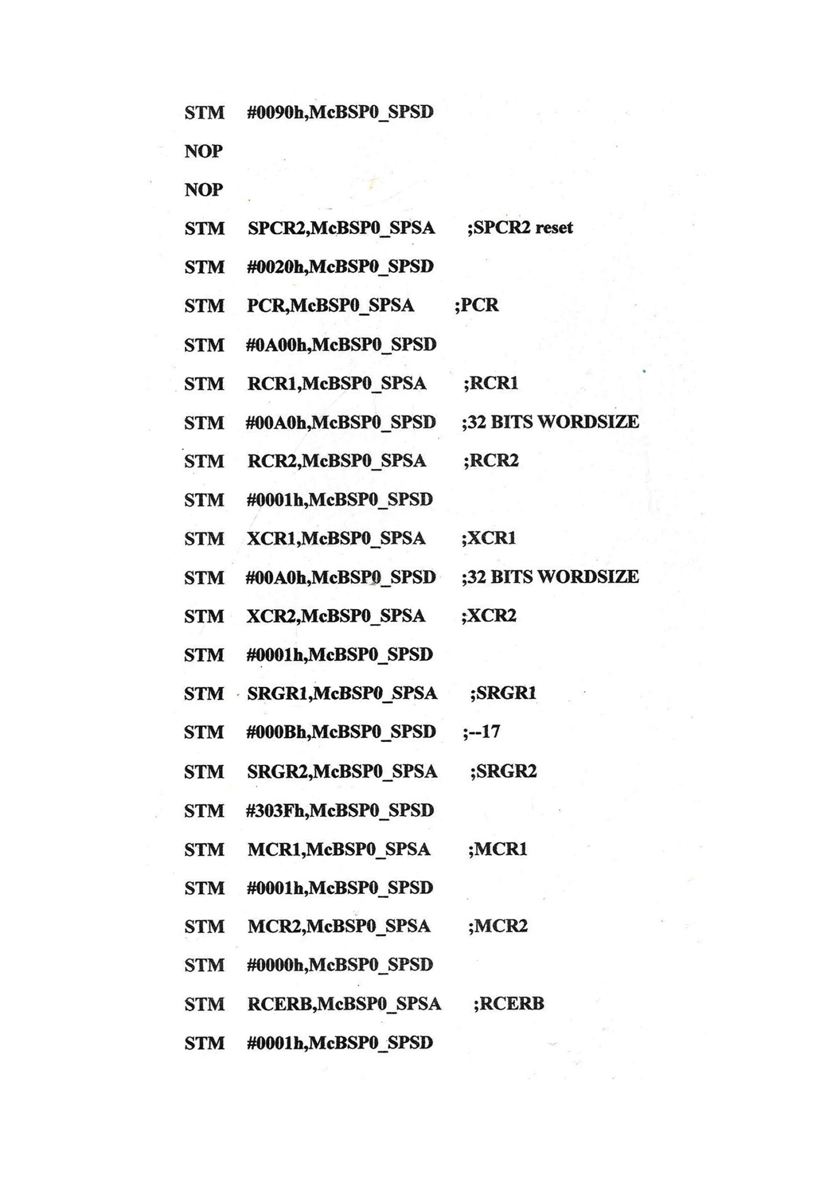

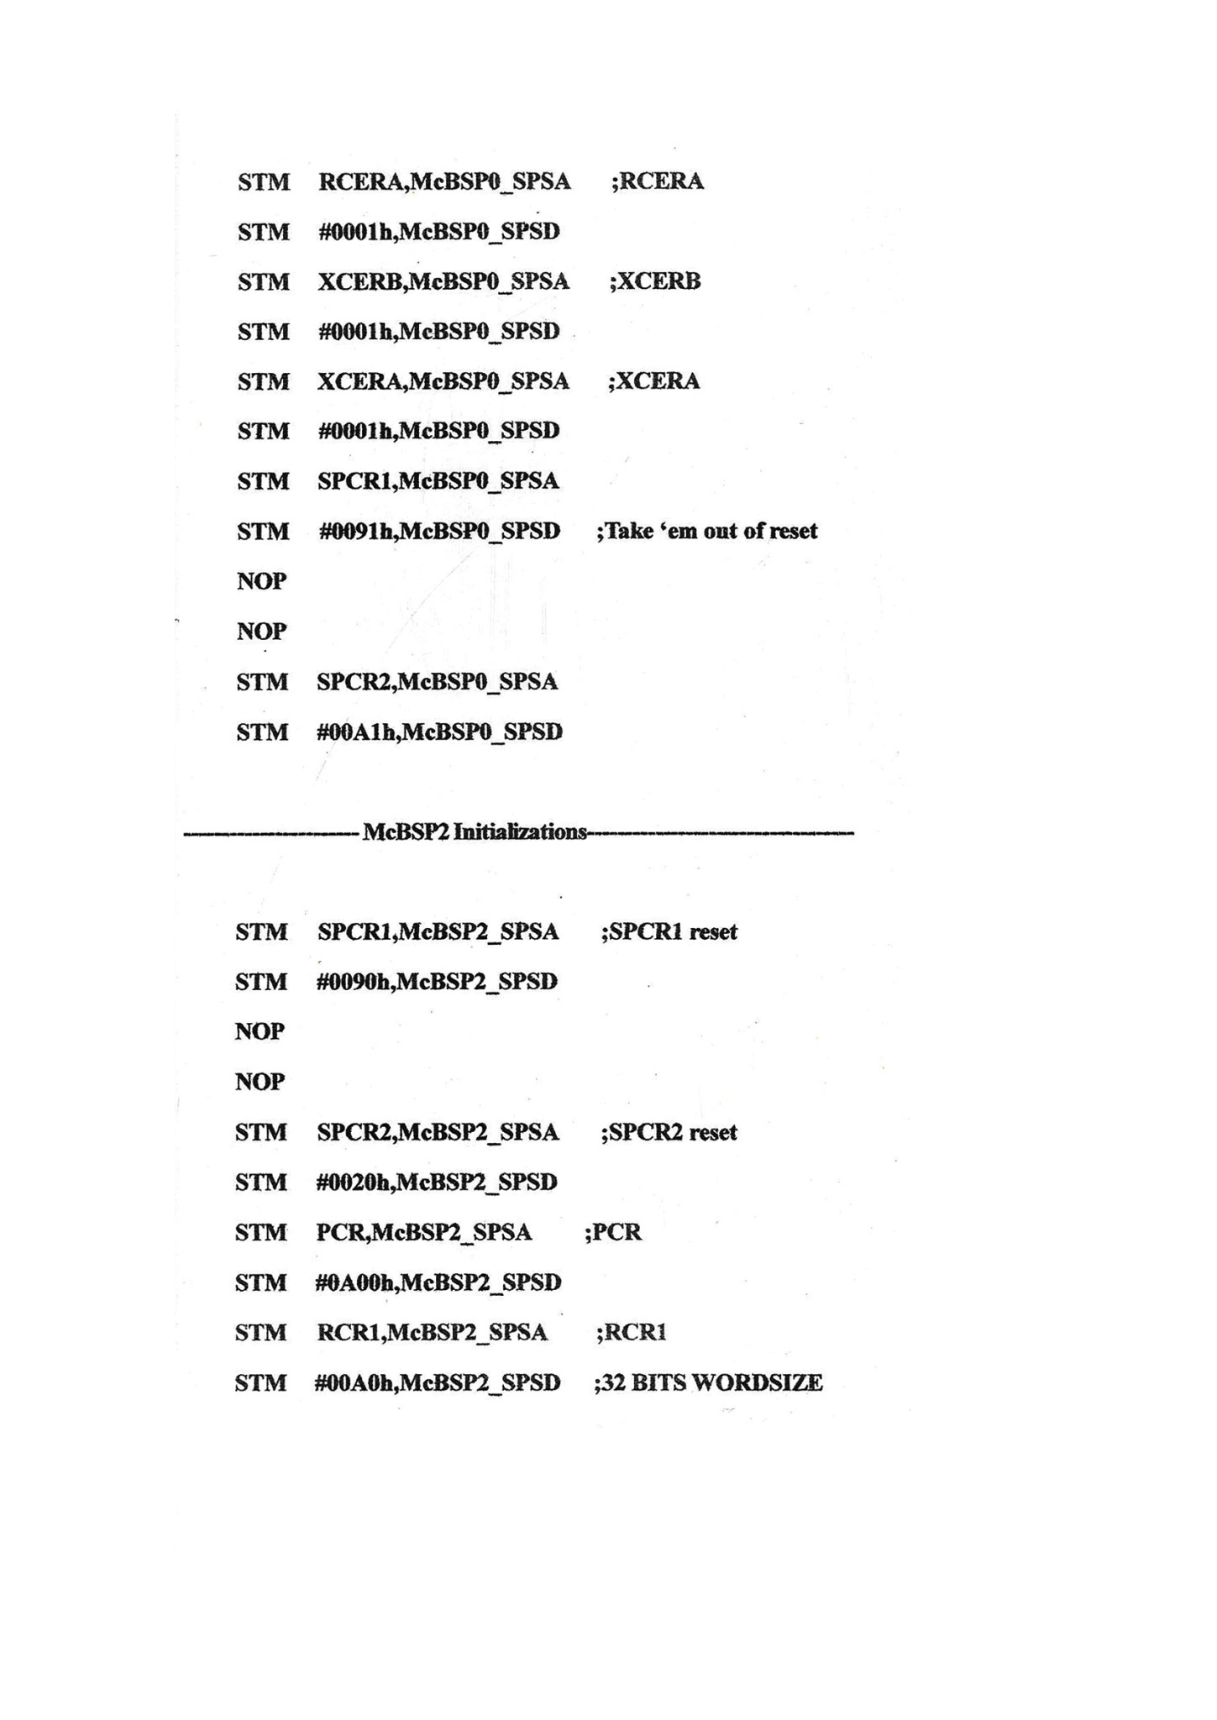

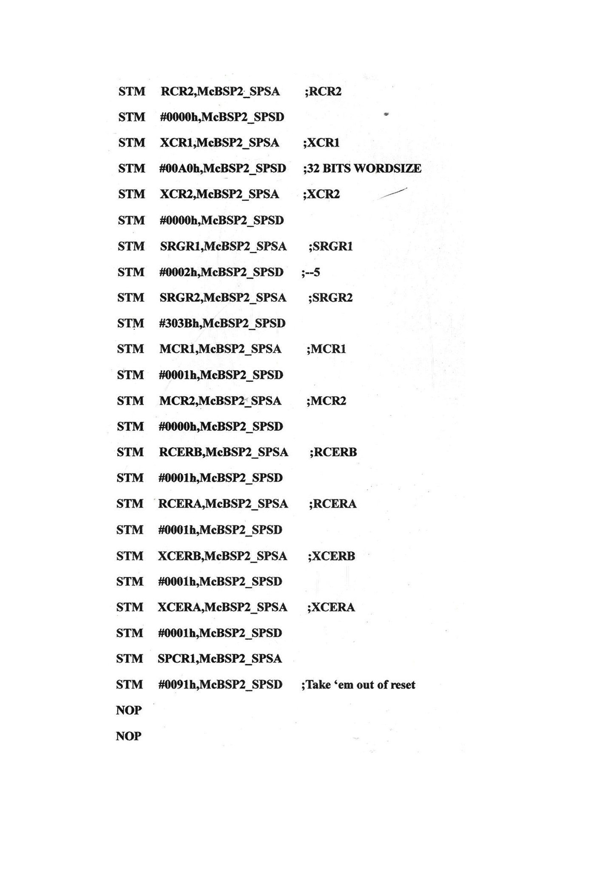

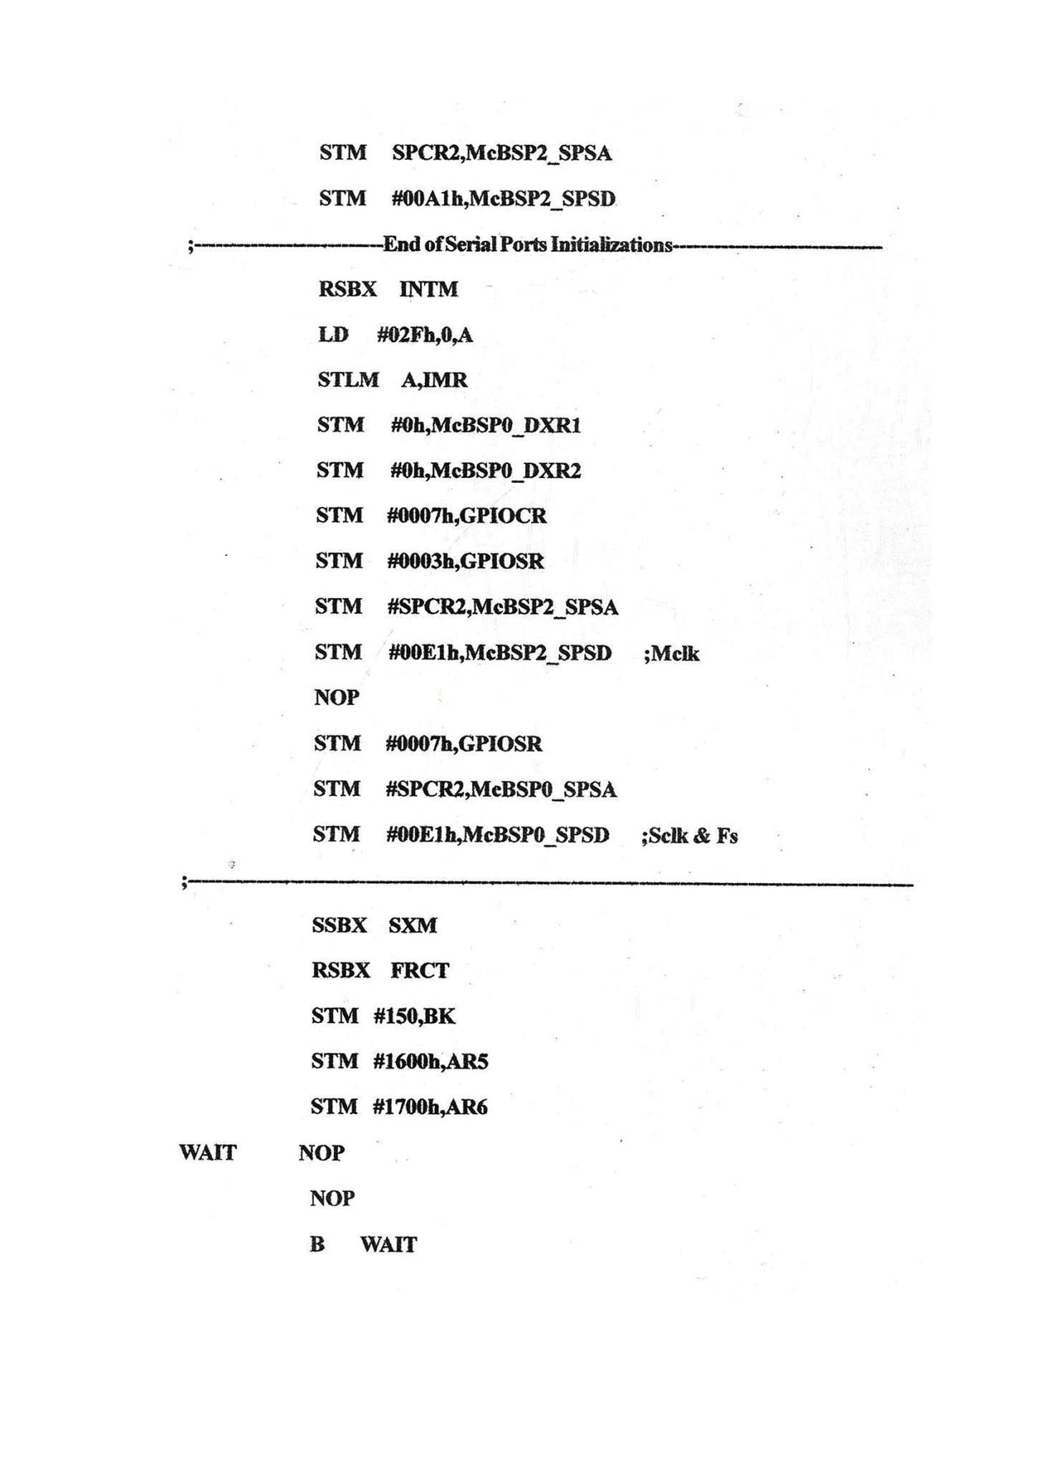

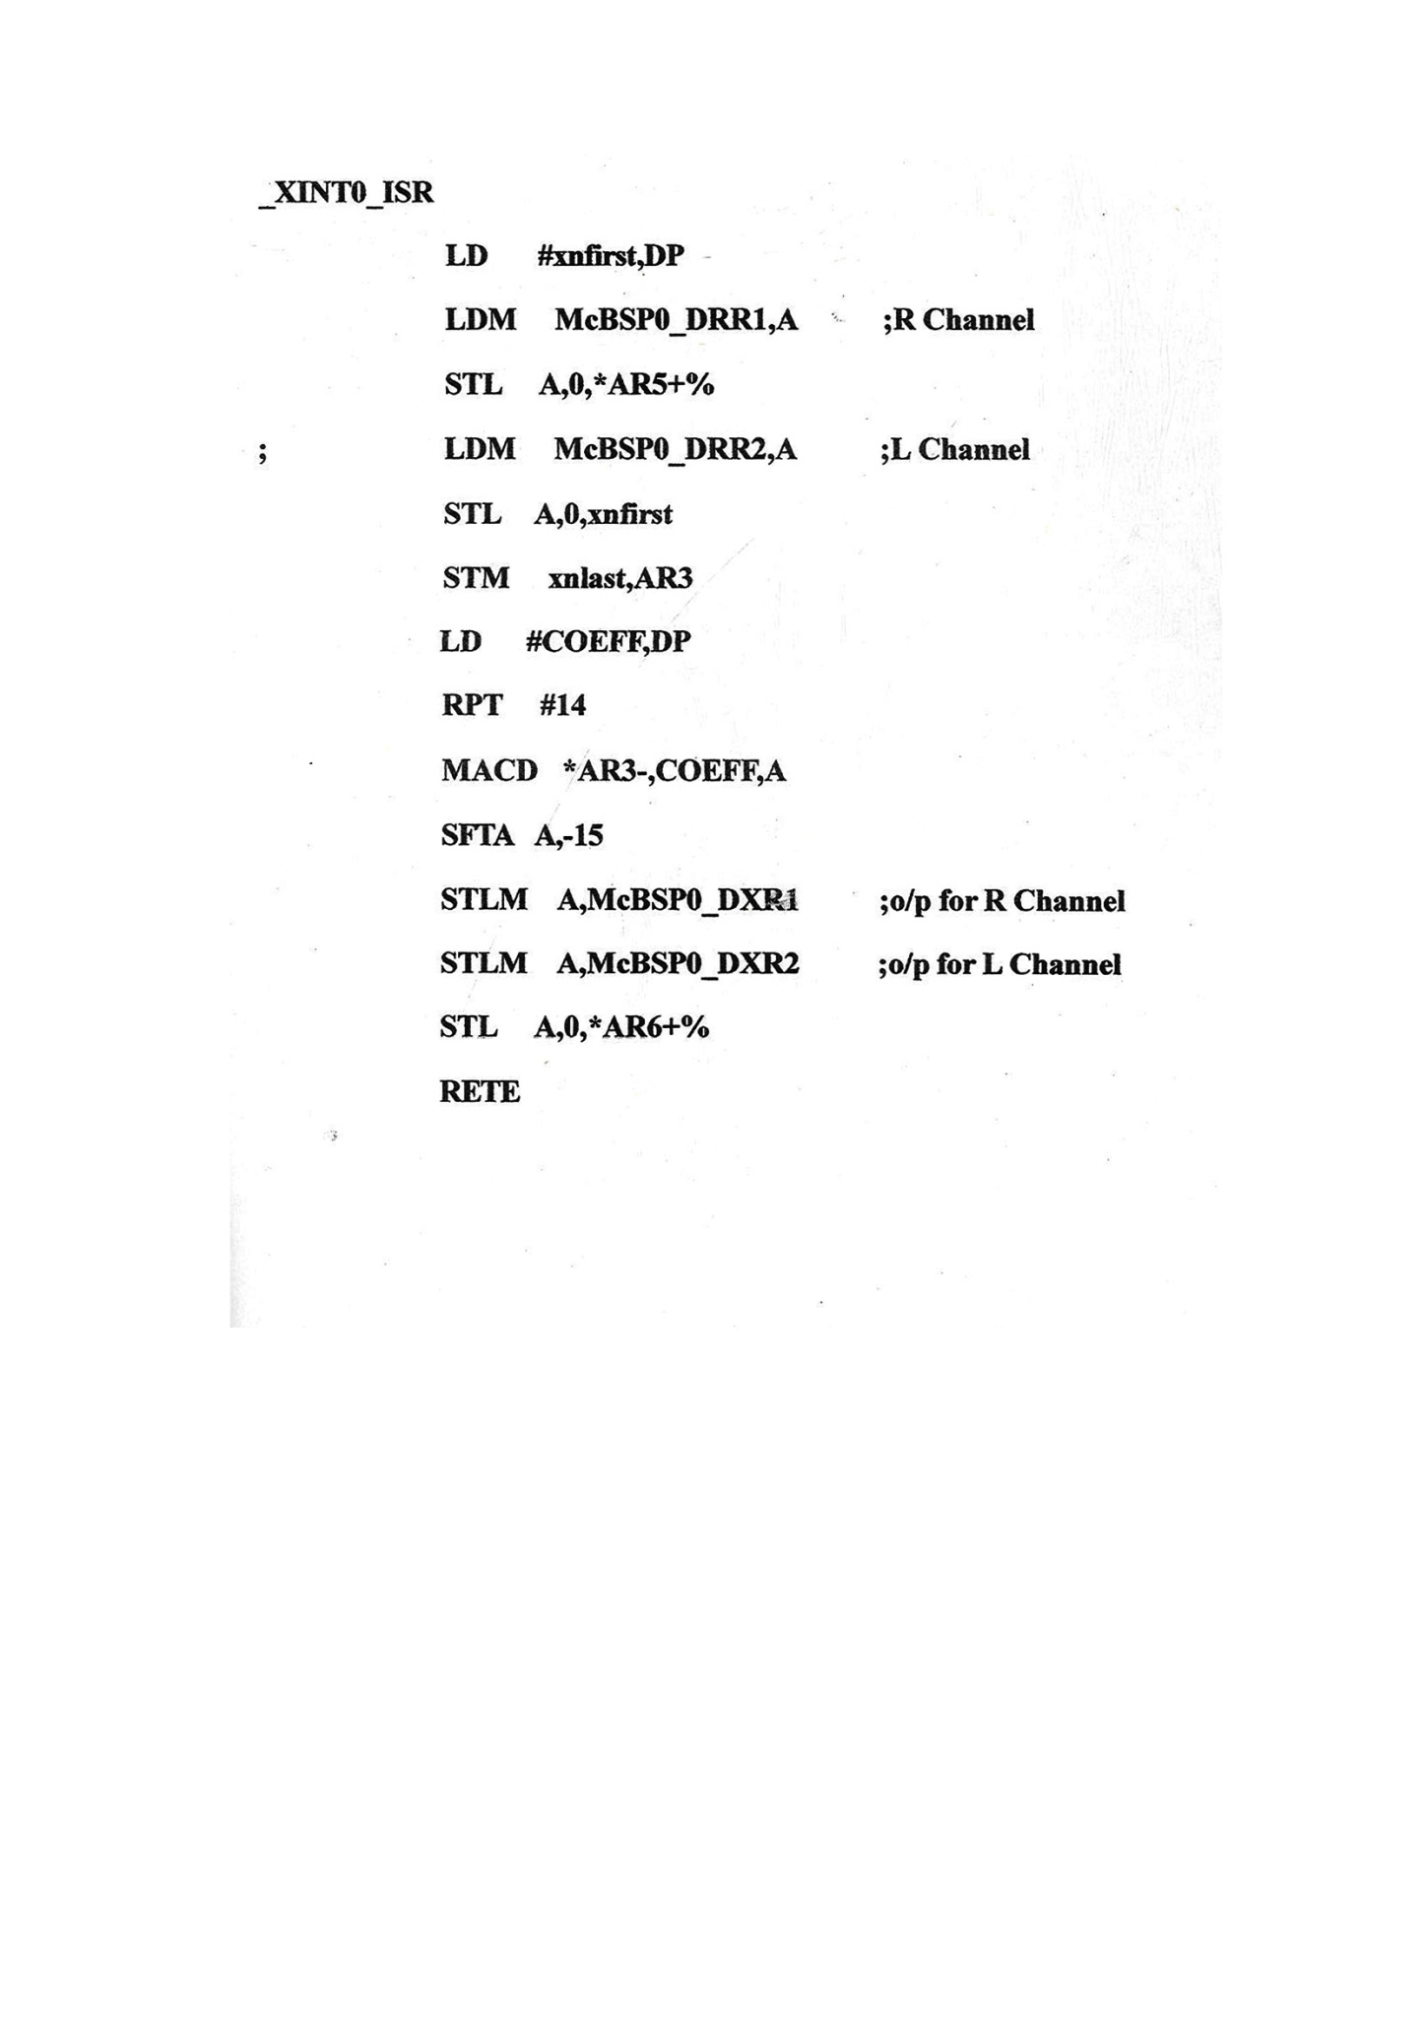

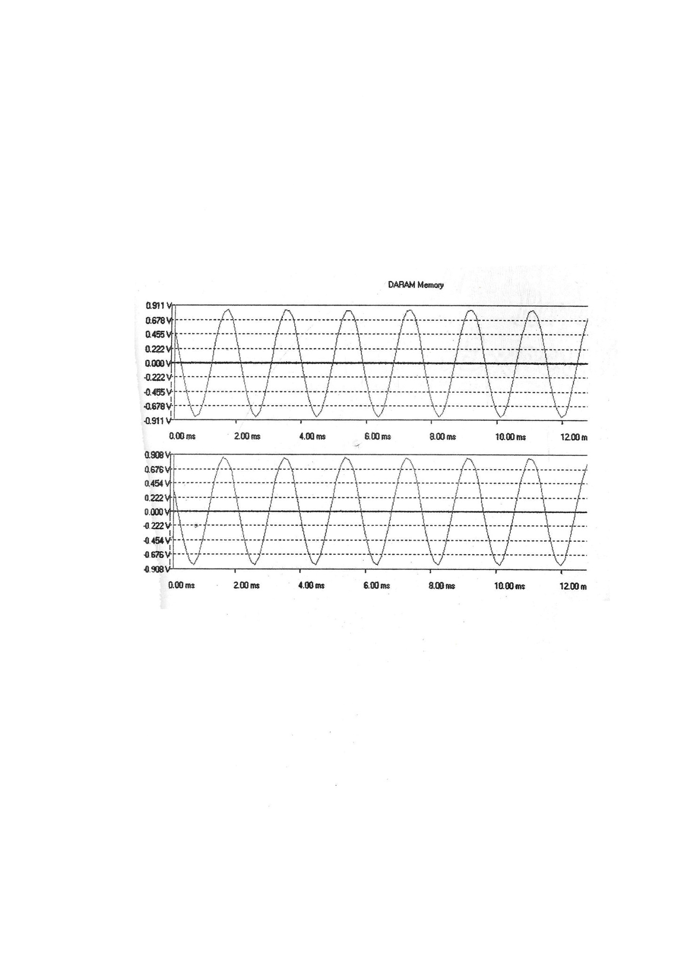

Result :

Ex. No : 15 | STUDY OF VARIOUS ADDRESSING MODES OF DSP | Date :

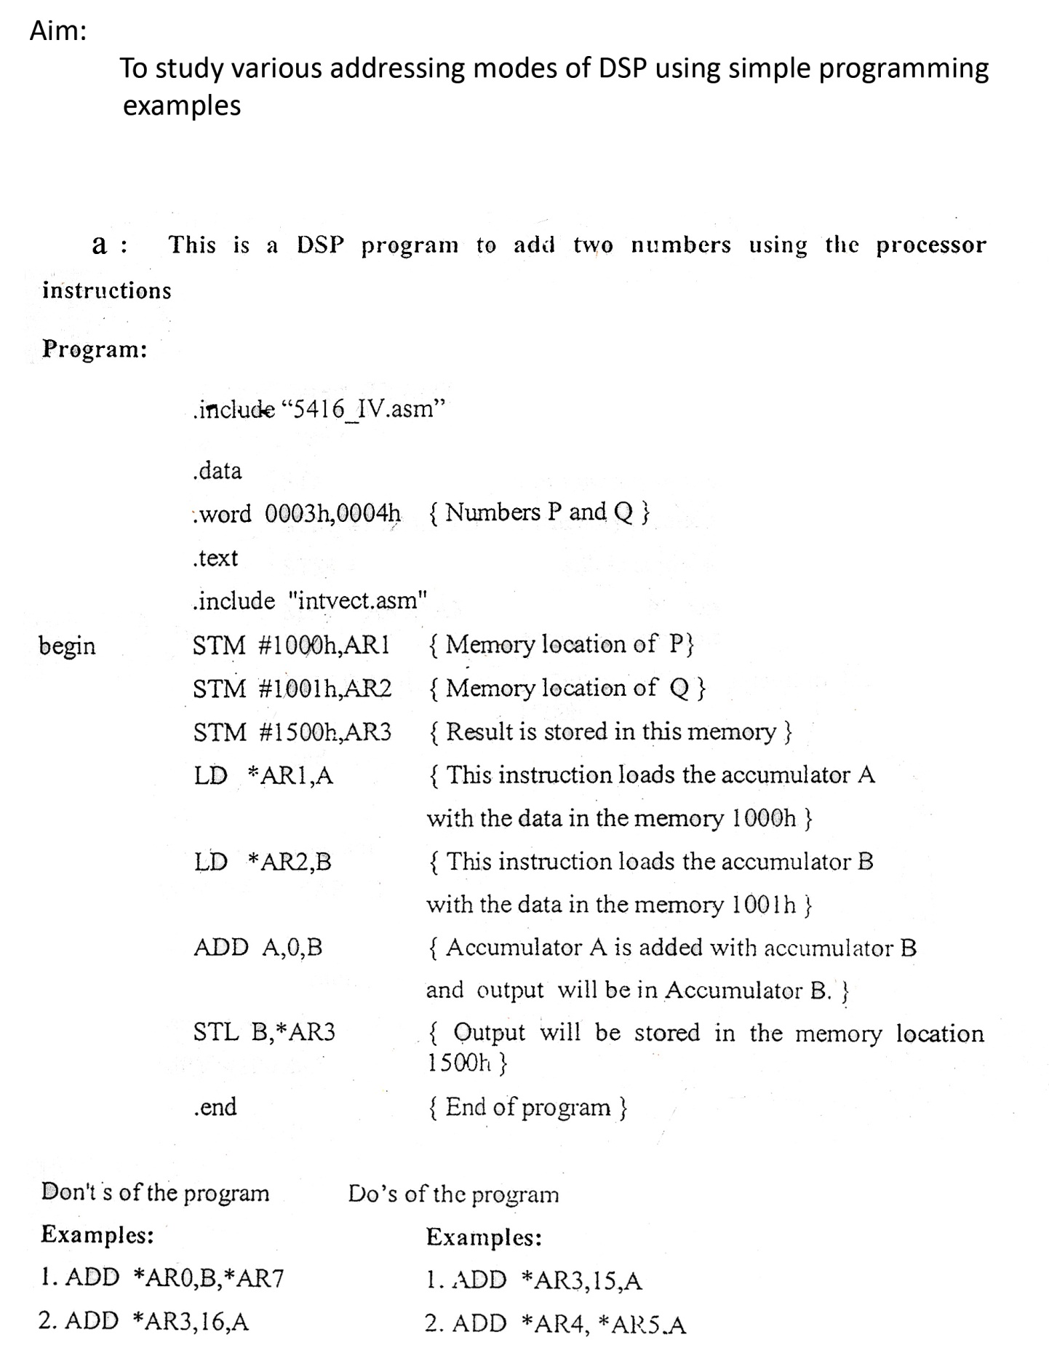

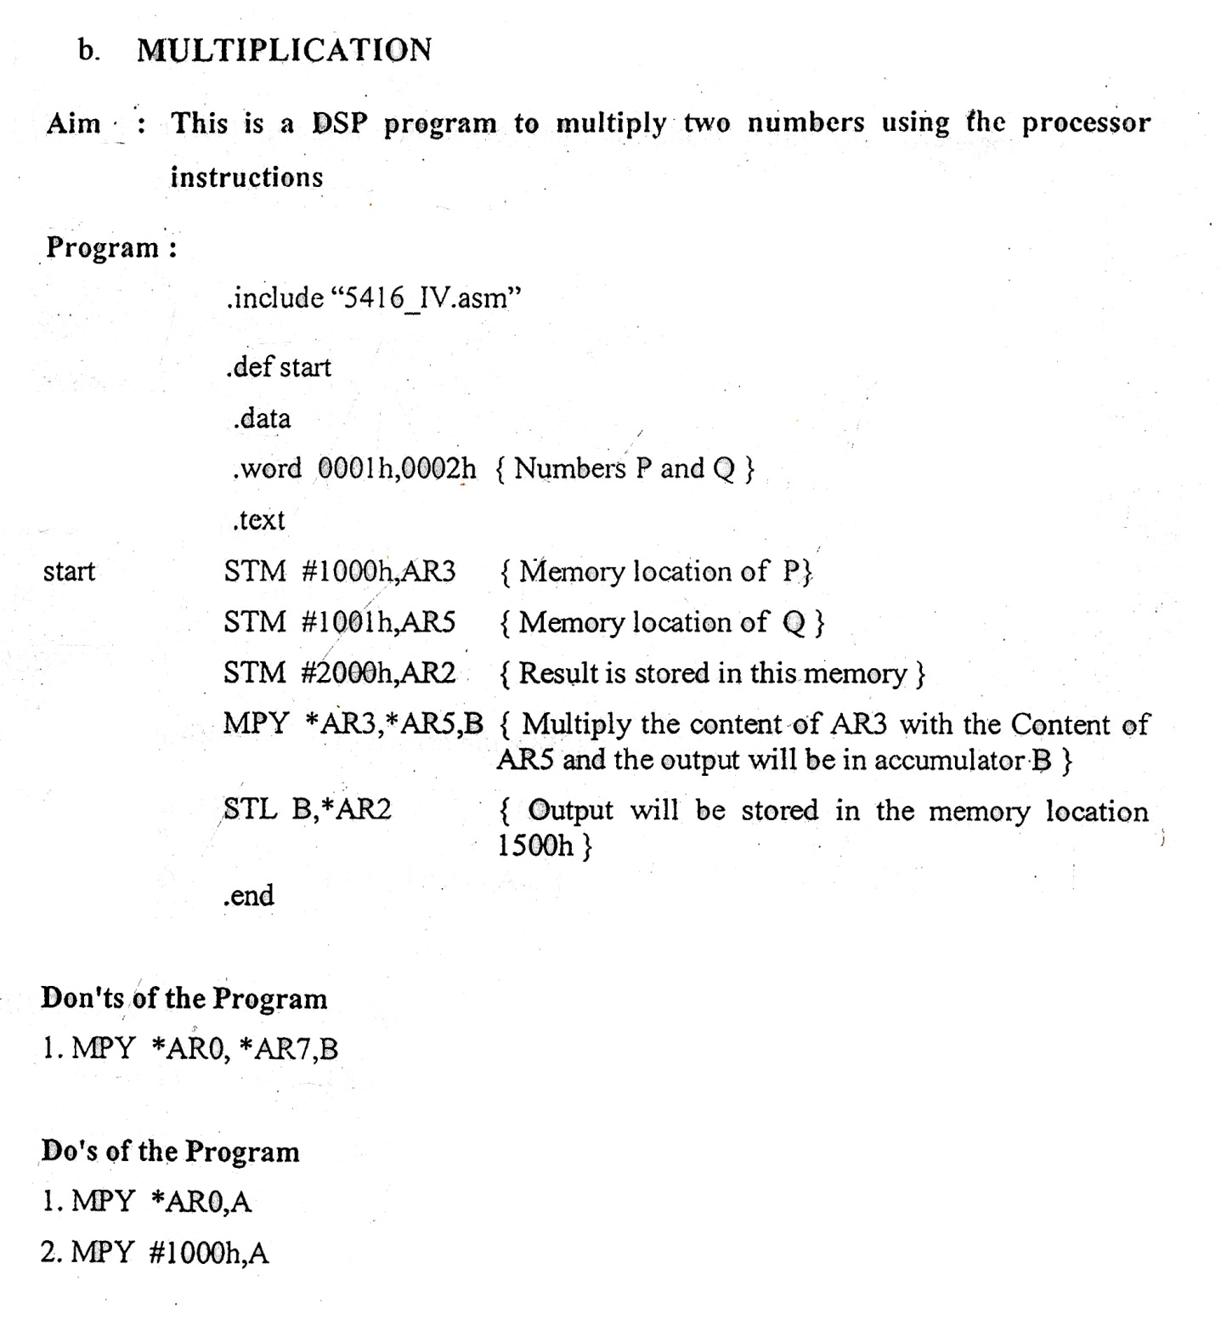

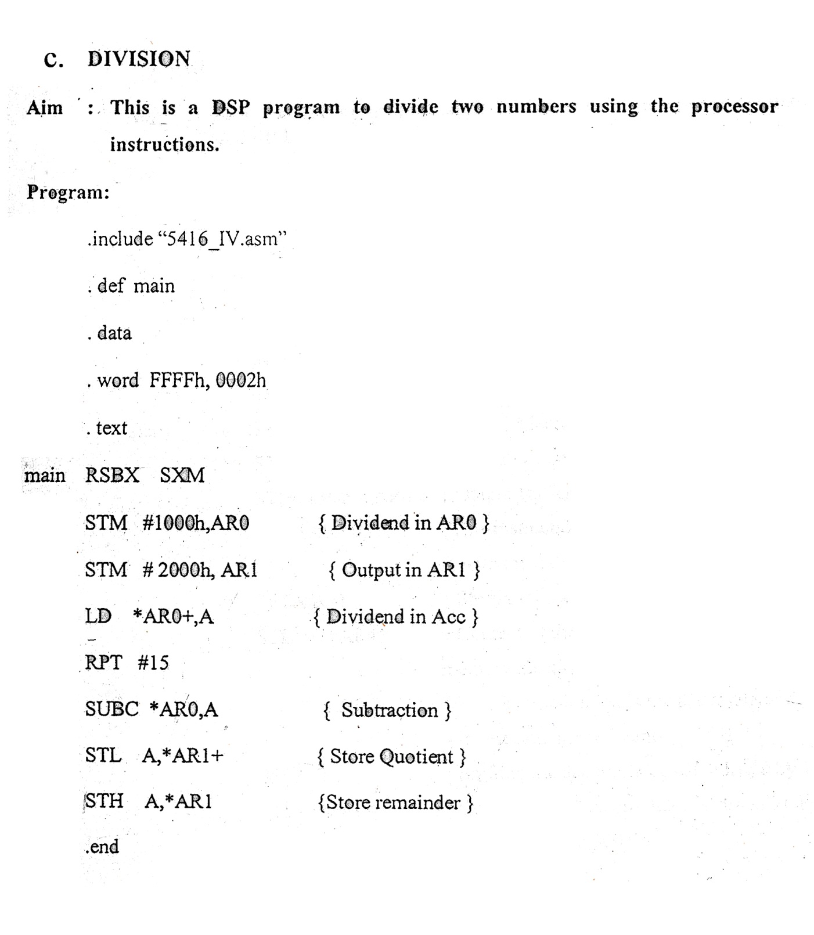

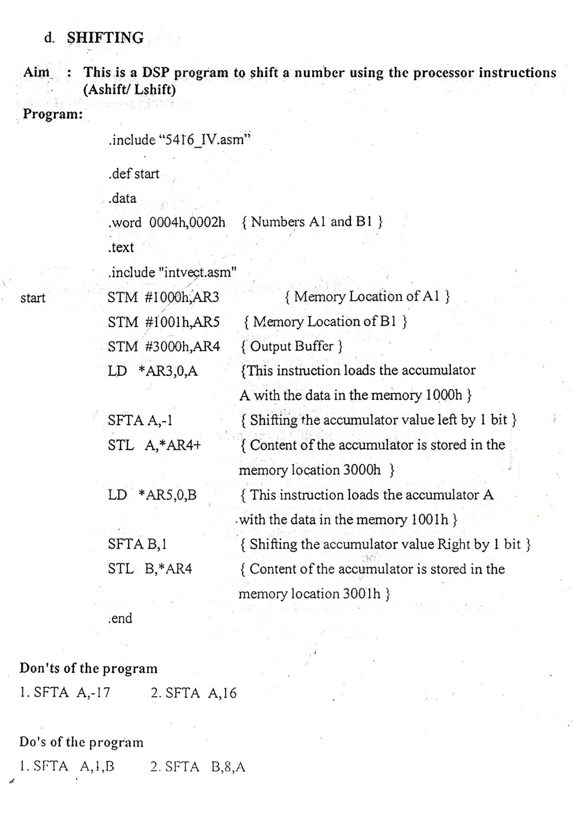

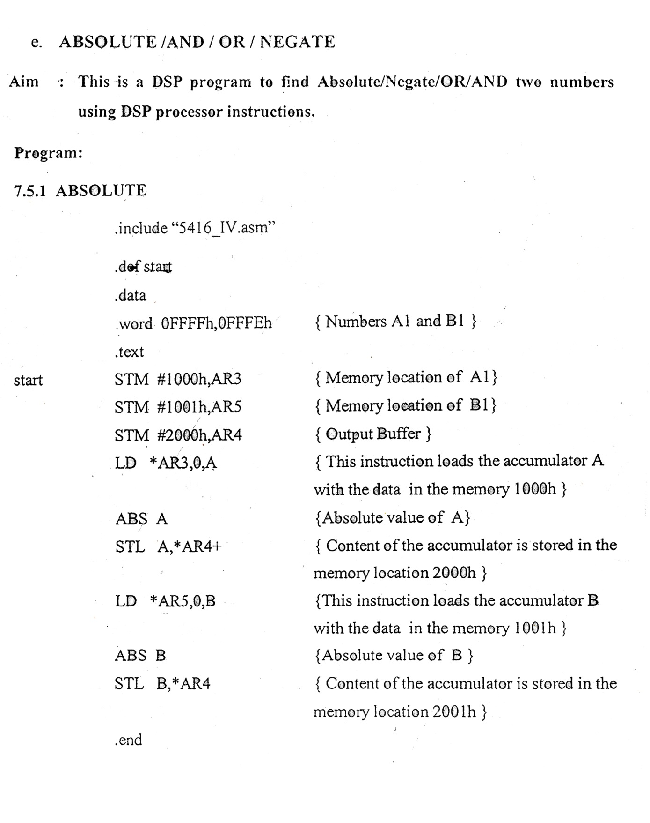

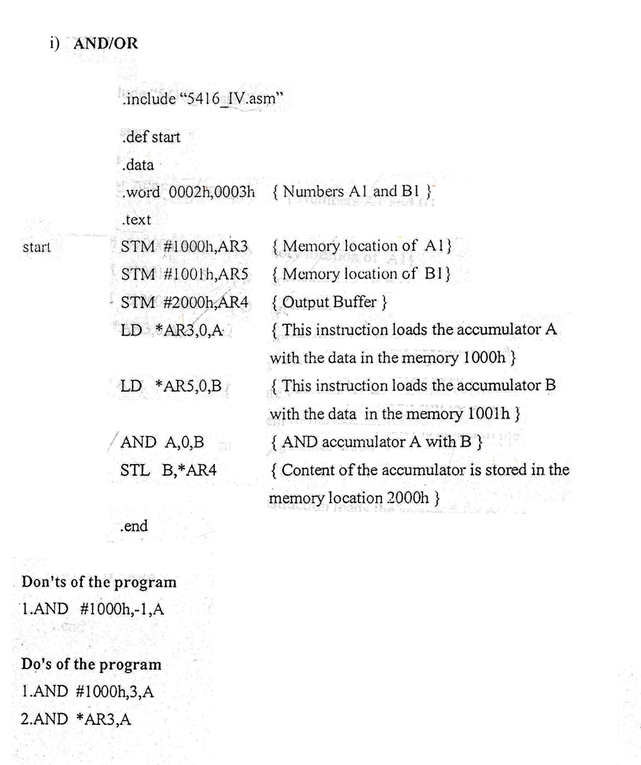

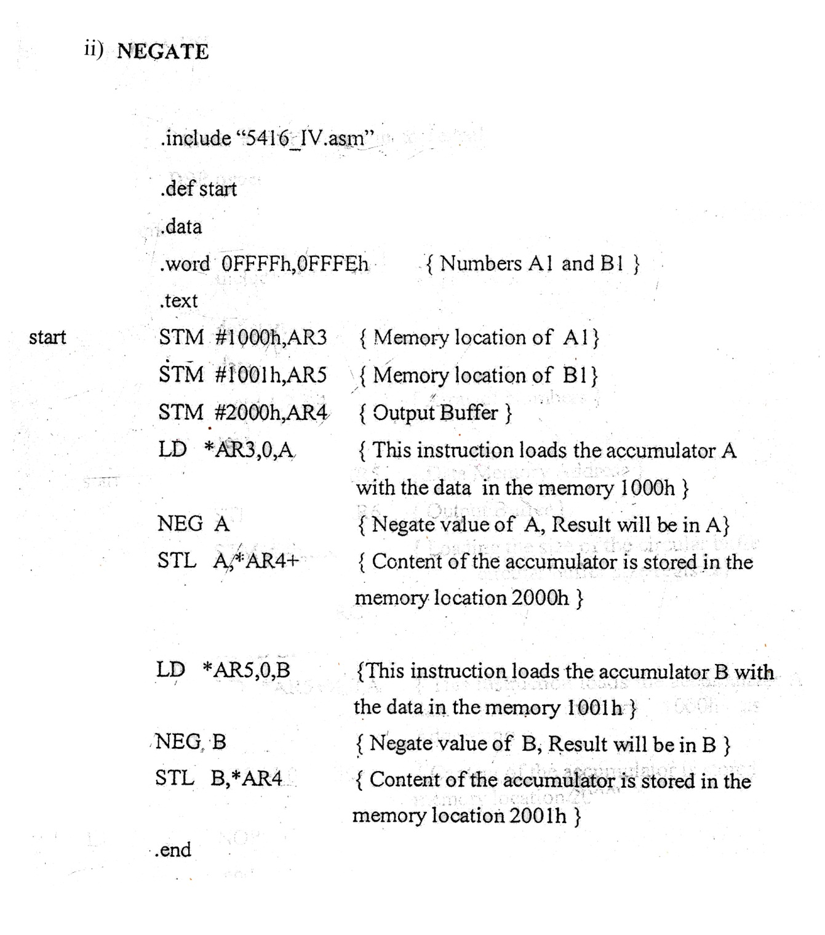

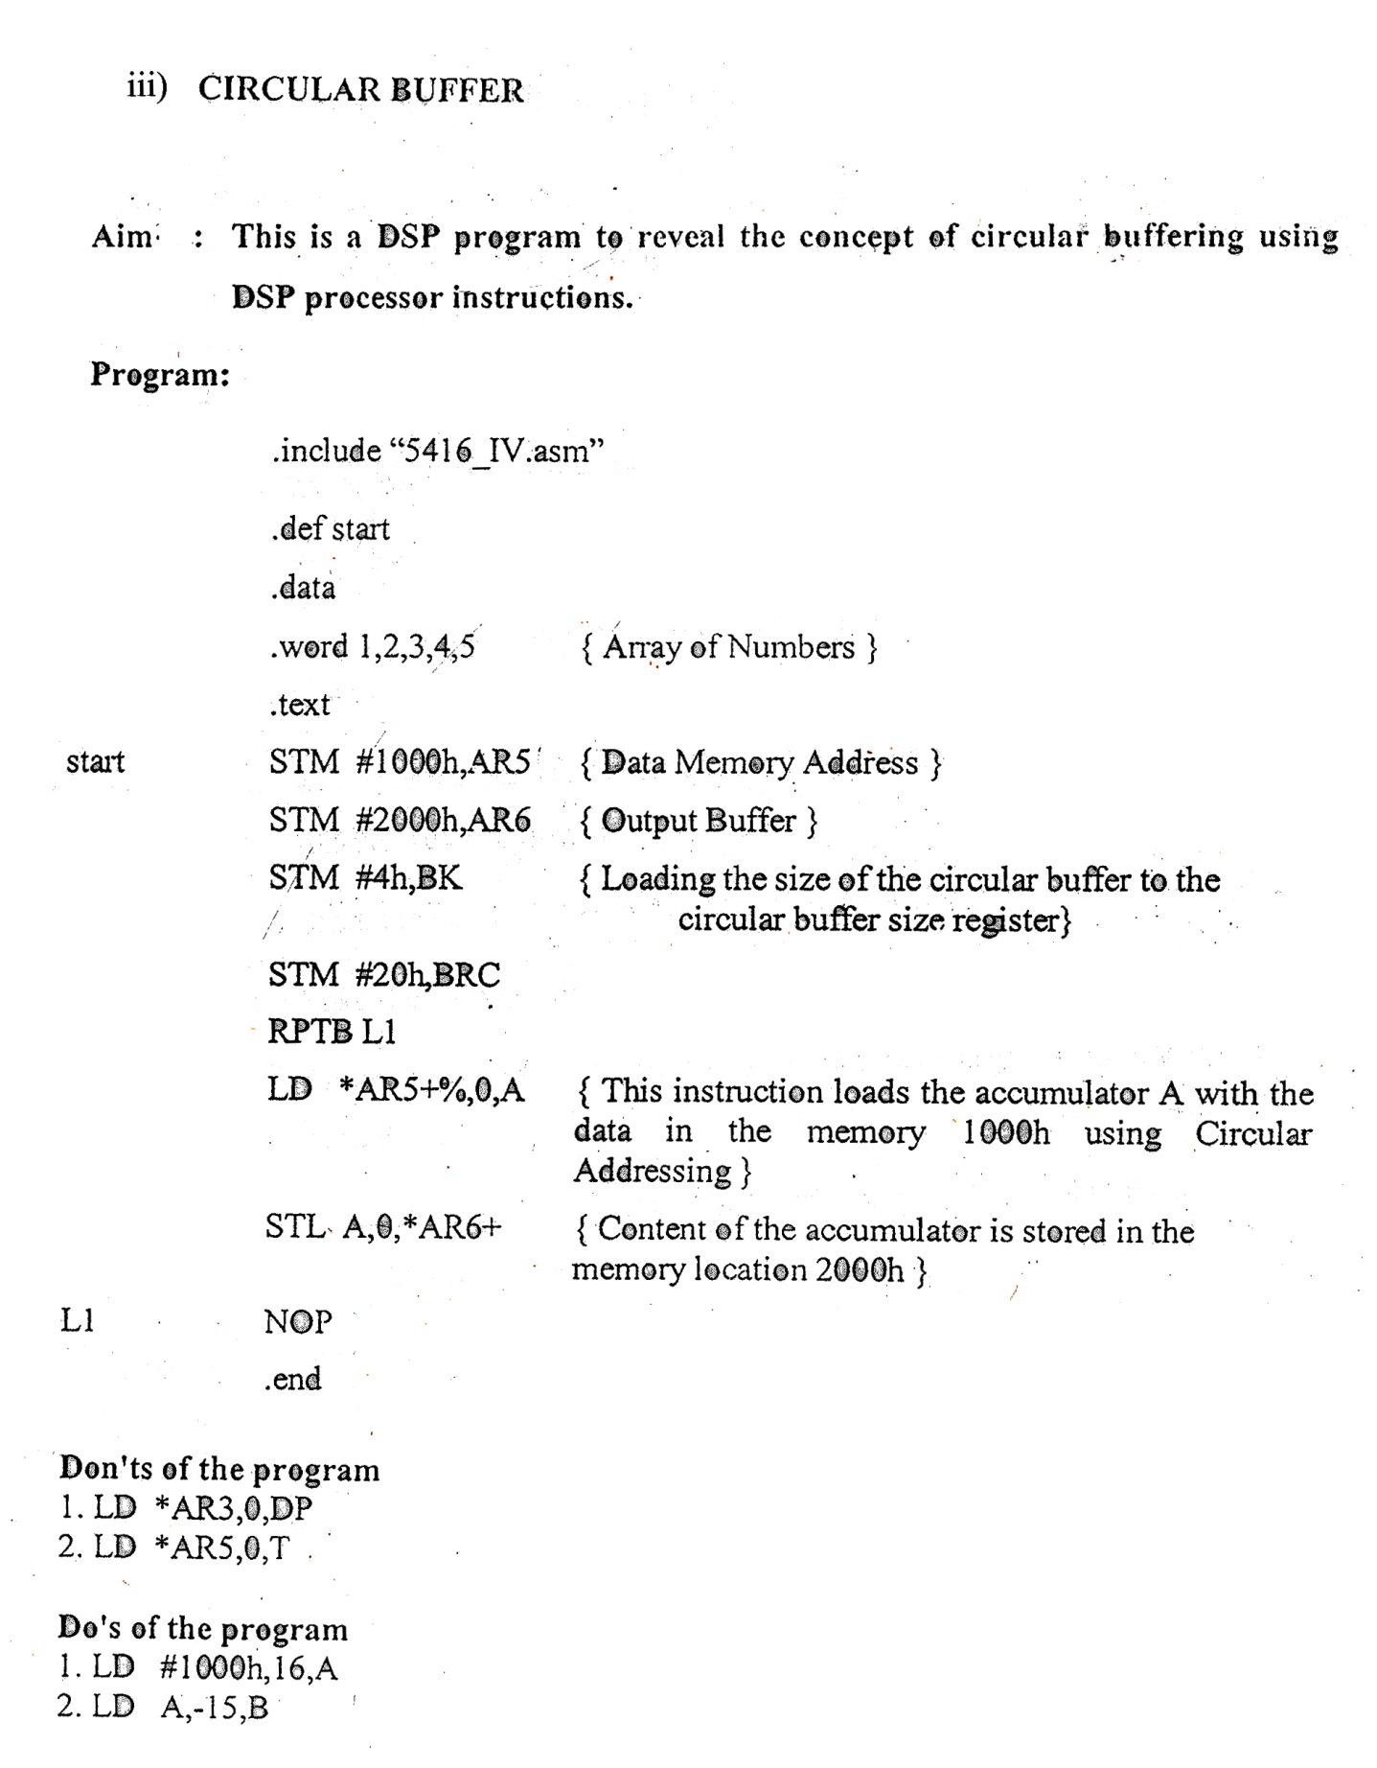

Result :

